1. Create your bit bucket account. Use your work email address to sign up.

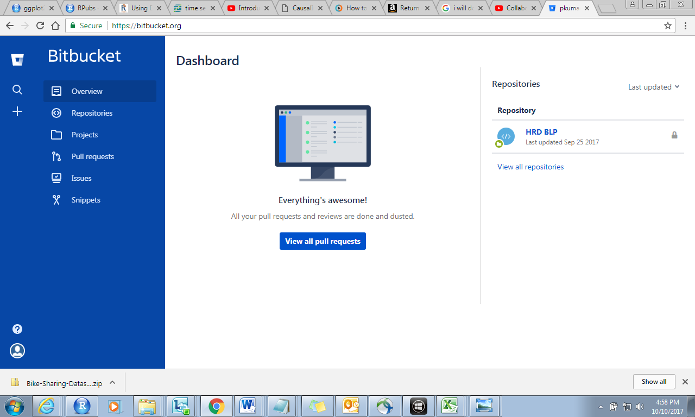

1. Create a new repository-Initialize a new repo or clone from existing repository.

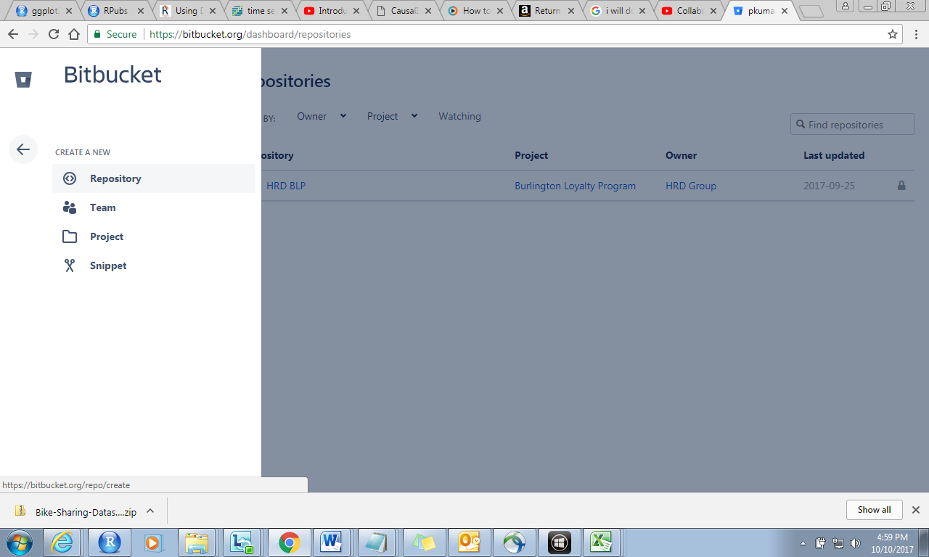

1. Copy the URL
2. 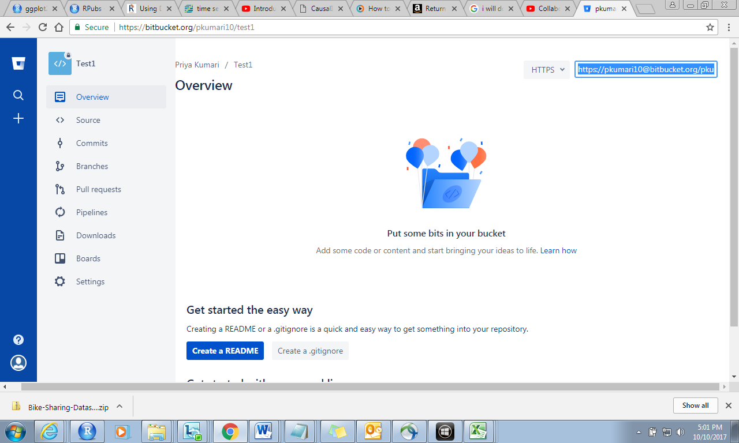

Create a new repo

Get the http url to place in R studio

In Rstudio:

Tools-global options—git/hub

Git executable- where git.exe file stored

c-program files-git-bn-git.exe

new project—3rd option—

repo url: url copied from repo In bitbucket

sub: give a local branch directory name.

check Staged—commit—pull--push